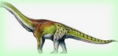
Acorn Class, Term 4 Topic – Dinosaurs
Enquiry Question – Who Made These Footprints?
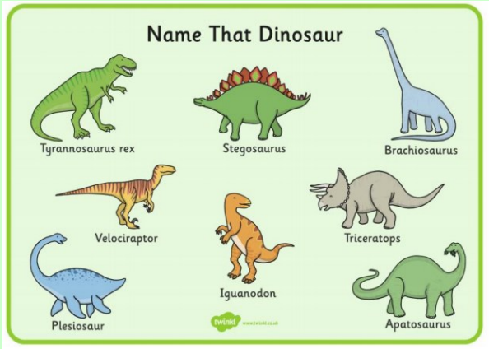  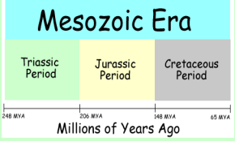  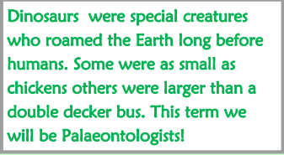 | 